Aux fuel tank ideas

Fuel bladders:
High on my list is the Turtle Pac Turtle Buddy

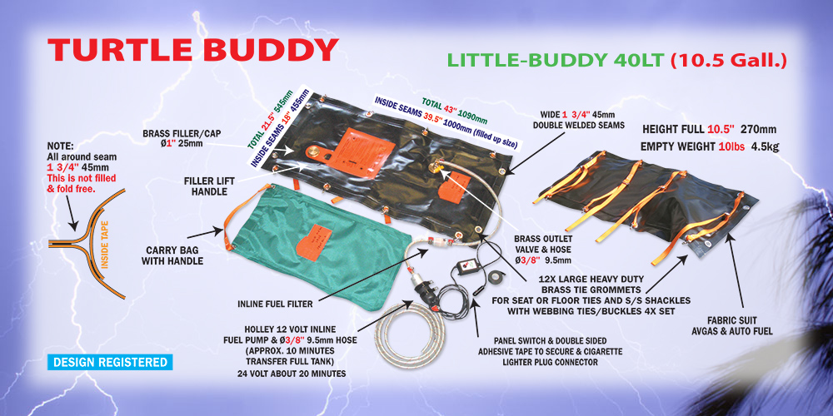<="">

I do really like the new Turtle Buddy with pump, hoses and carry case. It can be carried, although a bit heavy, fits in a seat and can be safely strapped in. The Turtle Buddy Kit comes with a 3/8 inch hose and Holly pump and a weird Australian switch. You just need to adapt the 3/8 output from the pump to the 5/16 inch hose inlet to the fuel tank. I always use a Colder Products Company quick disconnects, for ease of tank removal. Just unplug the wired switch, then disconnect the fuel quick disconnect and pull the tank. There is no vent.

Before the Turtle Buddy Kit there was just the rubber 40 liter tank. You just needed to buy a few other items to hook from the tank to the bladder.

As far as transfer, I like to use a Fascet pump at 30gph as it is perfect although a Holly works well also. I make up a plug in for the panel (cigarette lighter type plug) with a push button handgrip to run the pump when I want to. Never just put a on-off toggle switch as you will normally overflow the main tank and vent fuel overboard. If you replace the siphon bulb in the Europa Mod 53 long range tank for the mono, with a fuel pump and switch, that is how most of us prefer to transfer fuel. The siphon is not very enjoyable. Both the extended range tank and main tank go down together and you have no idea how much fuel you’ve transferred as you can’t see in the aux tank. The fuel pump does not lie.

I use the standard fuel boss from the bottom of the tank and fit it in the vent line and just dribble the gas in rather than the siphon method used by Europa.
The Europa uses 5/16 fuel line so I used the following:
Parts I use are
Turtle seat tank only without fittings:
Europa FO9E fuel fitting.
18 inches of 1/4 inch OD brass tubing
1/8NPT by 5/16 line for my vent line. If you desire use a 1/4 inch one which is standard. I just like a larger vent.
(The other side of the FO0E is a 5/16 nipple and you hook your fuel line from the pump to it.)
Colder Products Company 5/16 PLCD 22005 male nipple quick disconnect with shutoff.
Colder Products Company 5/16 PLCD 17005 female receptacle quick disconnect with shutoff.
Facet Fuel Pump (transfers at 30 gal per hour and empties the tank in 20 minutes). I transfer 5 gallons at a time to prevent getting the main tank too low.)
Summit racing hand held remote start switch.
10 feet of 5/16 inch R9 or better fuel line that meets EPA emissions (the hose has an inner liner and no smell comes through the rubber hose).
2 feet of 5/16 inch polyurethane or viton fuel tubing so you can see the fuel transferring from the tank.

If you buy the Turtle Buddy Kit your parts are:
Europa FO9E
18 inches of 1/4 inch OD brass tubing
Colder Products 3/8 inch barb nipple male quick disconnect with shutoff. (PLCD22006)
Colder products 5/16 inch barb nipple female quick disconnect with shutoff. (PLCD17005)
2 feet of 5/16 inch R9 or better fuel line that meets EPS emissions.

Solid Tanks:
Marine tanks have been used by some. Problem is there are no mounting brackets or hold down points and do not seal tight as they vent to the cabin. They are designed for an open boat. In a crash, expect them to split and explode unless modified to be sealed and fabricate a proper vent. Fuel should never vent to the cockpit.

One to consider which can be modified to be held down with multiple crisscrossed straps this one comes with fittings:
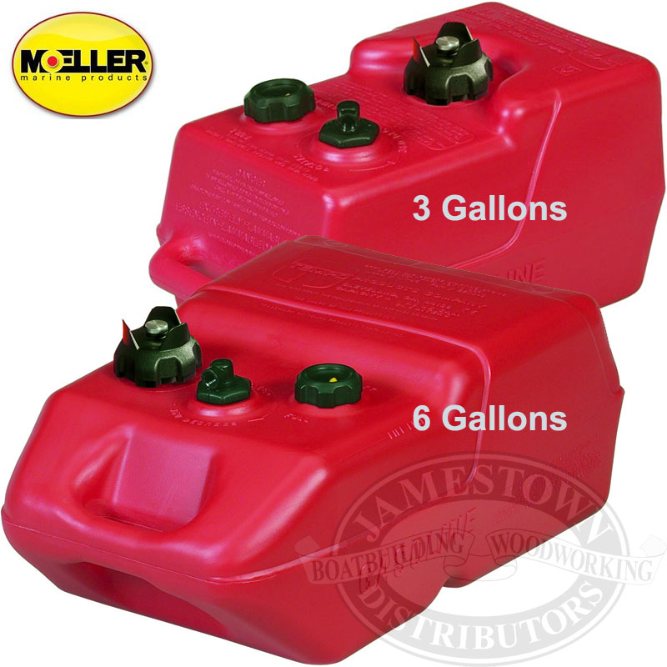
Moeller Marine EPA- Compliant Topside Fuel Tank — 6 Gallons, Low Profile, Model# 620049LP Dimensions are: 21.75"L x 13.75"W x 10.5"H"

I really don’t like these marine top side tanks. The vapor explosion possibility is not safe for a cockpit installation.

However, if you wish to anchor your tank down properly consider a racing fuel tank.
Many of these tanks are foam or even bladder lined with AN fittings. They are a bit heavy. They include vent fittings and are very rugged. I wouldn’t say crash proof, but a heck of a lot safer than bladders and plastic marine tanks.

Here is a foam filled plastic tank with strap hold down groves, AN fittings etc.

: 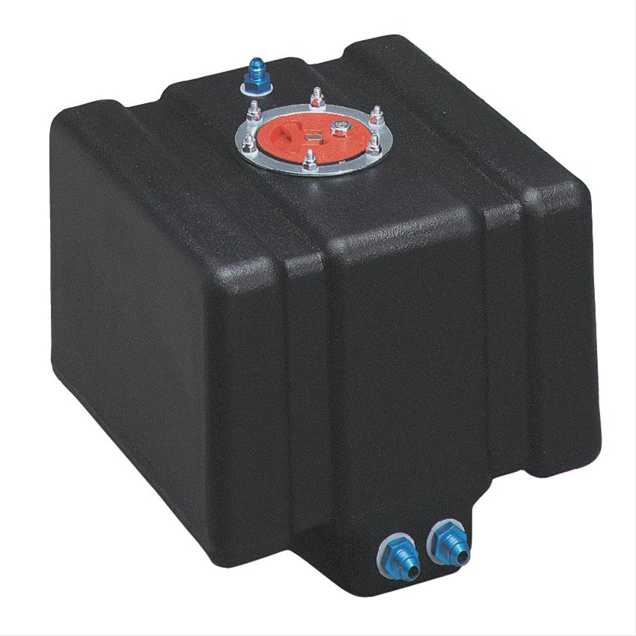
Aluminum foam filled antislosh tanks are only a bit more expensive:

- 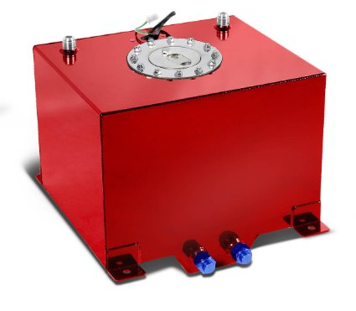
- 15" (L) x 12.5" (W) x 10" (H) / Mounting Tabs Measure: 13.75" (L) x 12.75" (W) Center to Center
- 8-Gallon Aluminum Street/Drift/Strip/Racing Fuel Cell Red Gas Tank with Level Sender and Silver Cap

