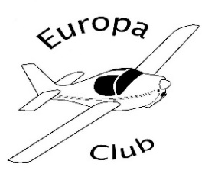 | AGM, Fly In and Annual Dinner  Friday, 26th July 2019

How good would it be to fly in to the annual dinner? This year, you can because the hotel is only a short distance from Wellesbourne Mountford Airfield [EGBW] and we have timed it in July to (almost) guarantee good flying weather! The airfield will be very happy to see a flock of Europas (and maybe a Liberty). The airfield is PPR at weekends so call 01789 842000.

The programme for the day is:
Fly in to Wellesbourne Mountford – suggest arrive end of morning
Lunch at the excellent Airfield restaurant
Walk to the Charlecote Pheasant (< ½ mile)
AGM in the Hampton Suite, Charlecote Pheasant - 3.00pm
Tea/coffee & biscuits - 4.00pm
Talk by Andy Draper - 4.30pm
Bar from 5.30pm
Dinner 7.00pm

The Charlecote Pheasant Hotel
Charlecote CV35 9EW
01789 279954

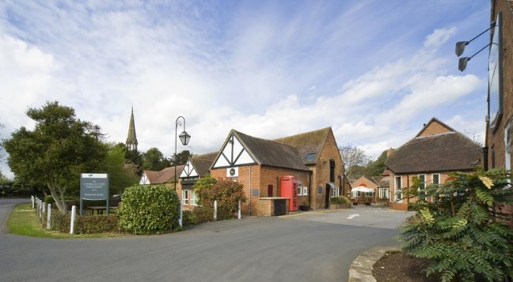

Booking: Please send the following information to trips@europaclub.org or post to David Joyce, Stone Mill, Woodford, Berkeley, GL13 9JU, by Friday,12th July 2019:
Name/s
Flying in Y/N – (We will give rough lunch numbers to airport restaurant)
Attending dinner
Menu choice/s
Confirmation of payment

Dinner Choice: Please select from the menu over leaf.

Starters Assiette of melon with mixed berry coulis (V)

Black pudding potato cake, crushed new potatoes topped with a poached egg
Smoked salmon, lemon wedge, capers & black pepper served with brown bread

Mains Roasted chicken breast with sage and onion stuffing and rich roast gravy

Loin of pork, cider apple sauce, braised red cabbage
Salmon fillet, Grilled asparagus, crushed new potatoes
All served with seasonal vegetables

Mushroom and pepper stroganoff served on a bed of rice (V)

Desserts Crème brulée, caramelised sugar, berries, shortbread
Brandy snap basket filled with fresh fruit
Cheese board – Chef’s trio of cheeses, biscuits, grapes

Freshly brewed coffee & mints

Payment for the dinner (£30/head) Please either pay by BACS - Account Name: The Europa Club; Sort Code: 60-05-16; Account No: 18590063 - quoting reference “Dinner” or send a cheque payable to the Europa Club to David.

Either way, payment should be made by Friday, 12th July 2019.

Hotel Booking:
The hotel is holding a number of double and twin rooms at a special rate of £109.00 including breakfast. Book your accommodation directly with the hotel on 01789 279954, quoting Europa Club, as soon as you can.

