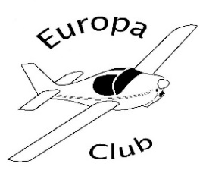 | The Annual Dinner  Saturday, 23rd September 2017

How good would it be to fly in to the annual dinner? This year, you can because the hotel is only a short distance from Wellesbourne Mountford Airfield [EGBW]. The airfield will be very happy to see a flock of Europas (and maybe a Liberty) on 23rd September. The airfield is PPR at weekends so call 01789 842000.

The Charlecote Pheasant Hotel
Charlecote CV35 9EW
01789 279954

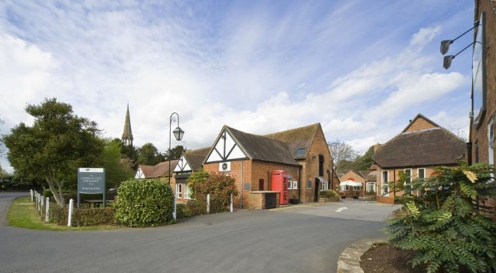

Dinner will be at 19.30 and will cost £28.00 per head. Please select from the menu below

Starters Chefs choice soup (V)
Game pate with toasted brioche
Smoked salmon, lemon wedge, capers & black pepper served with brown bread

Mains Roasted chicken breast with sage and onion stuffing and rich roast gravy

Lamb shank, slow cooked and very tender, served with a rich red wine & tomato sauce
Poached Salmon fillet topped with a champagne, lemon and basil sauce
All served with crushed new potatoes and seasonal vegetables

Mushroom and pepper stroganoff served on a bed of rice (V)

Desserts Cream filled profiteroles with warm chocolate sauce
Brandy snap basket filled with fresh fruit
Cheese board

Freshly brewed coffee & mints
and send a note of your choices to Irene Watson - irene.watson@ntlworld.com
- 37 Willowmead Close, Woking, GU21 3DN - 01483 714096
by Monday, 11th September 2017.
Please pay by BACS - Account Name: The Europa Club; Sort Code: 60-05-16; Account No: 18590063 - quoting reference “Dinner” or send a cheque payable to the Europa Club to Irene. Either way, payment should be made by Monday, 11th September 2017.
The hotel is holding a number of double and twin rooms at a special rate of £105.00 including breakfast. Book your accommodation directly with the hotel on 01789 279954, quoting Europa Club, before Saturday, 25th August 2017.

